Quality Assurance Handbook:
Part 9: Quality Assurance For Other Areas
This handbook provides advice and support for projects funded by JISC’s digital library programmes. The handbook provides advice for projects in their choice of standards, best practices and implementation architectures. The handbook provides a quality assurance methodology which will help to ensure that projects funded by JISC’s digital library programmes are interoperable and widely accessible.
This handbook addresses general issues.


Authors QA Focus team at UKOLN and AHDS
Publication date: 16 August 2004
Version: 1.1.
Published on 27 October 2005.


Table Of Contents

1 Introduction 1
Background 1
About QA Focus 1
Scope Of QA Focus 1
The QA Focus Team 2
2 About This Handbook 3
3 Advice On General QA Issues 4
Implementing A Technical Review 5
Using Instant Messaging Software 7
Introduction To Audio And Video Communication Tools 9
An Introduction To Podcasting 11
3 Case Studies On General QA Issues 13
Implementing a Communications Infrastructure 14
Acknowledgements 17

1 Introduction

Background
Welcome to QA Focus’s “Quality Assurance – General Issues” Handbook. This handbook has been published by the JISC-funded QA Focus project. The handbook provides advice on the quality assurance framework which has been developed by QA Focus.

About QA Focus
QA Focus has funded by the JISC to help develop quality assurance methodology which projects funded by JISC’s digital library programmes should seek to implement in order to ensure that project deliverables comply with appropriate standards and best practices which. This will help to ensure that project deliverables and widely accessible and interoperable and to facilitate the deployment of deliverables into a service environment.
The approach taken by QA Focus has been developmental: rather than seeking to impose requirements on projects, which are being undertaken by many institutions across the country, with differing backgrounds and levels of funding and resources, we have sought to raise an awareness of JISC’s commitment to use of open standards, to describe various technical frameworks which can help in deploying open standards and to outline ways of ensuring that selected standards and used in a compliance fashion.
We do, however, recognise the difficulties which projects may experience in implementing open standards (such as, for example, the immaturity of standards or the poor support for standards by tool vendors; the resource implications in implementing some of the standards; etc.). We have sought to address such concerns by developing a matrix framework to assist in the selection of standards which are appropriate for use by standards, in the light of available funding, available expertise, maturity of standard, etc.
We hope that the wide range of advice provided in this handbook will be valuable to projects. However the most important aspect of this handbook is the quality assurance QA methodology which is outlined in the handbook. The QA methodology has been developed with an awareness of the constraints faced by projects. We have sought to develop a light-weight QA methodology which can be easily implemented and which should provide immediate benefits to projects during the development of their deliverables as well as ensuring interoperability and ease of deployment into service which will help to ensure the maximum effectiveness of JISC’s overall digital library development work.

Scope Of QA Focus
QA Focus seeks to ensure technical interoperability and maximum accessibility of project deliverables. QA Focus therefore has a focus on the technical aspects of project’s work.
Our remit covers the following technical aspects:
Digitisation: The digitisation of resources, including text, image, moving image and sound resources.
Access: Access to resources, with particular references to access using the Web.
Metadata: The use of metadata, such as resource discovery metadata.
Software development: The development and deployment of software applications.
Service deployment: Deployment of project deliverables into a service environment.
In addition to these core technical areas we also address:
Standards: The selection and deployment of standards for use by projects.
Quality assurance: The development of quality assurance procedures by projects.
QA Focus’s was originally funded to support JISC’s 5/99 programme. However during 2003 our remit was extended to support JISC’s FAIR and X4L in addition to 5/99.

The QA Focus Team
QA Focus began its work on 1 January 2002. Initially the service was provided by UKOLN and ILRT, University of Bristol. However, following ILRT’s decision to re-focus on their core activities they left QA Focus and were replaced by the AHDS on 1 January 2003.
This handbook has been developed by the current QA Focus team members: Brian Kelly, UKOLN (QA Focus project leader), Amanda Closier (QA Focus officer), Marieke Guy, UKOLN (former QA Focus officer), Hamish James, AHDS (QA Focus project leader at AHDS) and Gareth Knight (QA Focus officer).

2 About This Handbook
This handbook provides advice on general quality assurance issues.
The handbook forms part of a series of Quality Assurance handbooks, which cover the areas which have been addressed by QA Focus work:
Part 1: About Quality assurance: The development of quality assurance procedures by projects.
Part 2: Quality Assurance For Standards: The selection and deployment of standards for use by projects.
Part 3: Quality Assurance For Digitisation: The digitisation of resources, including text, image, moving image and sound resources.
Part 4: Quality Assurance For Web/Access: Access to resources, especially access using the Web.
Part 5: Quality Assurance For Metadata: The use of metadata, such as resource discovery metadata.
Part 6: Quality Assurance For Software: Development and deployment of software applications.
Part 7: Quality Assurance For Service Deployment: Deployment of project deliverables into a service environment.
Part 8: Quality Assurance For Legal Issues: Quality assurance related to legal issues.
Part 9: Quality Assurance In Other Areas: Quality assurance in areas not covered elsewhere.
The handbook consists of three main sections:
Briefing Documents: Brief, focussed advice on best practices.
Case studies: Descriptions of the approaches taken by projects to the deployment of best practices.
Toolkit: Self-assessment checklists which can help ensure that projects have addressed the key areas.

3 Advice On General QA Issues
Background
This section addresses general QA issues. The briefing documents seek to describe best practices in this area.
Briefing Documents
The following briefing documents which address the general QA issues have been produced:
- Implementing A Technical Review (briefing-33)
- Using Instant Messaging Software (briefing-56)

Implementing A Technical Review
About This Document
This briefing document provides advice on implementing a technical review of your project.
Citation Details
Implementing A Technical Review, QA Focus, UKOLN,
<http://www.ukoln.ac.uk/qa-focus/documents/briefings/briefing-33/>
Keywords: technical review, QA, briefing
Introduction
When projects submit an initial proposal the project partners will probably have an idea as to the approaches which will be taken in order to provide the project deliverables. During the project’s life it may be desirable to review the approaches which were initially envisaged and, if necessary to make changes. This document describes possible approaches to periodic reviews.
Reasons For A Review
There are a number of reasons why a technical review may be necessary:
Technological issues: There may be changes with underlying technologies. For example the software which was initially envisaged being used may be found to be inappropriate or alternative software may be felt to provide advantages.
Staffing issues: There may be staffing changes. For example key technical staff may leave and are difficult to replace.
Organisational issues: There may be changes within the organisation which is providing the project.
Changing requirements: There may be changes in the requirements for the project, following, say, a user needs requirements survey.
Ensure that deliverables comply with standards and best practices: It may be necessary to ensure that the project has implemented quality assurance processes to ensure that project deliverables comply with appropriate standards and best practices.
A project review may, of course, also address non-technical issues.
Approaches To A Review
Projects may find it useful to allocate some time during the project life span to a technical review of the project.
Review by development team: The project development team may wish to reflect on the approaches they have taken. They may be encouraged to provide a report to the project manager.
Review by project partners: The project partners may be involved in the review process.
Review involving third parties: The project team may wish to invite external bodies to participate in the review.
Comparison with one’s peers: You may chose to compare your deliverables with your peers, such as similar projects. This approach is particular suited for reviewing publicly available deliverables such as Web sites.
When organising a project review you should take care to ensure that the review is handled in a constructive manner.
Outputs From A Review
It is important to note that any improvements or changes which may have been identified during a view need not necessarily be implemented. There may be a temptation to implement best practices when good practices are sufficient, and that implementation of best practices may take longer to implement than envisaged. The outputs from a review may be:
Better understanding: The review may have an educational role and allow project partners to gain a better understanding of issues.
Enhanced Workflow Practices: Rather than implementing technical changes the review may identify the need for improvements to workflow practices.
Documenting lessons: The review may provide an opportunity to document limitations of the existing approach. The documentation could be produced for use by project partners, or could be made more widely available (e.g. as a QA Focus Case Study).
Deployed in other areas: The recommendations may be implemented in other areas which the project partners are involved in.
Implemented within project: The recommendations may be implemented within the project itself. If this is the case it is important that the change is driven by project needs and not purely on technical grounds. The project manager should normally approve significant changes and other stakeholders may need to be informed.
Conclusions
It can be useful to allocate time for a mid-project review to ensure that project work is proceeding satisfactorily. This can also provide an opportunity to reassess the project’s technical architecture.

Using Instant Messaging Software
About This Document
This briefing document gives advice on policy issues which should be addressed when making use of instant messaging with project partners.
Citation Details
Using Instant Messaging Software, QA Focus, UKOLN,
<http://www.ukoln.ac.uk/qa-focus/documents/briefings/briefing-56/>
Keywords: IM, instant messaging, policy, briefing
About Instant Messaging
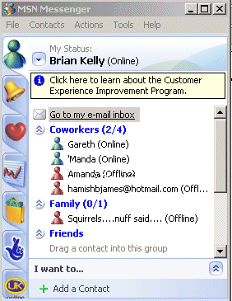
Instant messaging (IM) is growing in popularity as the Internet becomes more widely used in a social context. The popularity of IM in a social context is leading to consideration of its potential for work purposes in providing real time communications with colleagues and co-workers.
Popular IM applications include MSN Messenger, Yahoo Messenger and AOL Messenger [1]. In addition to these dedicated applications a number of Web-based services also provide instant messaging facilities within the Web site, such as YahooGroups [2]. The JISCMail list management service has also released an instant messaging facility [3].
The Benefits
Instant Messaging software can provide several benefits:
- The immediacy provided by instant communications
- Avoiding swamping list members with unnecessary messages
- Various value-added features, such as sharing desktop applications
Instant messaging fans appreciate the immediacy of communications it provides, which can be particularly valuable when working on small-scale concrete tasks.
Possible Problems
There is a need to be aware of potential problems which can be encountered when using instant messaging software:
- Need to install an appropriate IM client
- Lack of interoperability across IM clients from different vendors.
- Dealing with interruptions.
- Lack of an archive of discussions, missing messages when away, etc.
- Difficulties in following discussions when used by several people.
Critics of instant messaging argue that, although IM may have a role to play for social purposes, for professional use email should be preferred.
Policies For Effective Use of Instant Messaging
Instant messaging may prove particularly useful when working with remote workers or if you are involved in project work with remote partners. However in order to make effective use of instant messaging tools there is a need to implement a policy governing its usage which addresses the problem areas described above.
Software: You will have to select the IM software. Note you may find that users already have an ID for a particular IM application and may be reluctant to change. There are multi-protocol IM tools available, such as Trillian [4] and IM+ [5] although you should be aware that these may have limited functionality.
Usage: You will need to define how instant messaging is to be used and how it will complement other communications channels, such as email.
Privacy, security, etc issues: You will need to define a policy on dealing with interruptions, privacy and security issues.
Records: You will need to define a policy on recording instant messaging discussions. Note that a number of IM clients have built-in message archiving capabilities.
As an example of a policy on use of instant messaging software see the policy produced for the QA Focus project [6] together with the QA Focus case study [7]. As an example of use of IM in an online meeting see the transcript and the accompanying guidelines [8].
References
- Instant Messenger FAQs, University of Liverpool, <http://www.liv.ac.uk/CSD/helpdesk/faqs/instant/>
- YahooGroups, <http://groups.yahoo.com/>
- DISCUSS Discussion Room at JISCMail, JISCMail, <http://www.jiscmail.ac.uk/lists/discuss.html>
- Trillian, Cerulean Studios, <http://www.ceruleanstudios.com/>
- IM+, Shape Services, <http://www.shapeservices.de/eng/im/>
- Policy on Instant Messaging, QA Focus, UKOLN,
<http://www.ukoln.ac.uk/qa-focus/qa/policies/instant-messaging/>
- Implementing A Communications Infrastructure, QA Focus, UKOLN, <http://www.ukoln.ac.uk/qa-focus/documents/case-studies/case-study-12/>
- Approaches To Web Development: Online Discussion, UK Web Focus, UKOLN,
<http://www.ukoln.ac.uk/web-focus/events/online/VLS-aug-2001/>

Introduction To Audio And Video Communication Tools
About This Document
This briefing document provides an introduction to audio and video communication tools.
Citation Details
Introduction To Audio And Video Communication Tools, QA Focus, UKOLN,
<http://www.ukoln.ac.uk/qa-focus/documents/briefings/briefing-79/>
Keywords: audio, video, briefing
Background
Audio and video applications are being increasingly used to support project working across distributed project teams. This document aims to give a brief description of audio and video tools which can be used to support such collaborative work within our institutions and to summarise the main challenges to be faced when considering their deployment across organisations.
The Potential For Audio And Video Tools
The growth in broadband is leading to renewed interest in audio and video-conferencing systems. In the past such services often required use of specialist hardware and software. However tools are now being developed for home use. This briefing document explores some of the issues concerning use of such technologies within an institution.
An Example Of An Audio Tool
The Skype Internet telephony system [1] is growing in popularity. Skype is popular because it can provide free calls to other Skype users. In addition Skype has potential for use in an academic context:
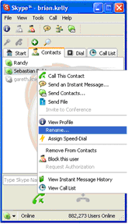
- High quality sound is often experienced between broadband users.
- It can provide cheap overseas calls.
- It can be used to set up conferences calls.
- It is integrated with instant messaging.
- It can be used to provide a sense of presence – e.g. remote users can participate in seminars, etc.
- It may provide accessibility benefits.
- Video extensions are available [2].
It should be noted, however, that Skype is a proprietary application and concerns over its use have been raised.
Examples Of Video Tools
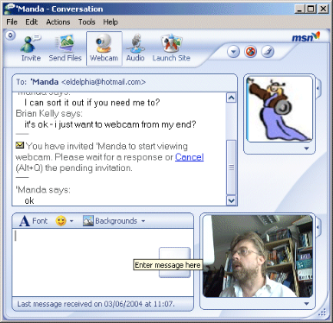
Instant Messaging clients such as MSN Messenger [3] also provide audio and video capabilities. Such tools can raise expectations of student users who may wish to use such tools for their own use.
It should be noted, however, that there are interoperability problems with such tools (e.g. both users may need to run the latest version of the MS Windows operating system). In addition the management of user IDs and setting up areas for group discussions may be issues.
An alternative approach is use of software such as VRVS [4]. This Web-based system provides managed access to virtual rooms, etc. VRVS is intended for use by GRID users and may not be appropriate for certain uses. However it does illustrate an alternative application.
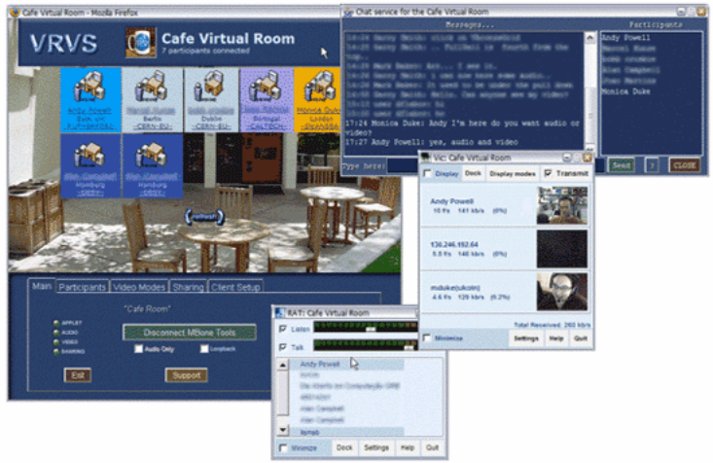
Issues
Issues which need to be addressed when considering use of such tools include:
- Are such tools needed? How will it co-exist with services such as email?
- How should the potentially disruptive aspect of audio tools be addressed?
- If felt to be needed, in what areas?
- What support infrastructure needs to be provided?
- Are there any technical, security, performance or other barriers to be addressed?
Further Information
- Skype, <http://www.skype.com/>
- HomeSpontania, <http://www.video4im.com/>
- MSN Messenger, <http://messenger.msn.com/>
- Virtual Rooms, Virtual Meetings, A. Powell, Ariadne, issue 41, Oct 2004, <http://www.ariadne.ac.uk/issue41/powell/>
An Introduction To Podcasting
About This Document
This briefing document provides an introduction to Podcasting.
Citation Details
Introduction To Audio And Video Communication Tools, QA Focus, UKOLN,
<http://www.ukoln.ac.uk/qa-focus/documents/briefings/briefing-83/>
Keywords: Podcasting, briefing
What Is Podcasting?
Podcasting has been described as “a method of publishing files to the internet, often allowing users to subscribe to a feed and receive new files automatically by subscription, usually at no cost.” [1].
Podcasting is a relatively new phenomena becoming popular in late 2004. Some of the early adopters regard Podcasting as a democratising technology, allowing users to easily create and publish their own radio shows which can be easily accessed. From a technical perspective, Podcasting is an application of the RSS 2.0 format [2]. RSS can be used to syndicate Web content, allowing Web resources to be automatically embedded in third party Web sites or processed by dedicated RSS viewers. The same approach is used by Podcasting, allowing audio files (typically in MP3 format) to be automatically processed by third party applications – however rather than embedding the content in Web pages, the audio files are transferred to a computer hard disk or to an MP3 player – such as an iPod.
The strength of Podcasting is the ease of use it provides rather than any radical new functionality. If, for example, you subscribe to a Podcast provided by the BBC, new episodes will appear automatically on your chosen device – you will not have to go to the BBC Web site to see if new files are available and then download them.
It should be noted that providing MP3 files to be downloaded from Web sites or a VLE (Virtual Learning Environment) is sometimes described as Podcasting, but this term strictly refers to the automated distribution mechanism using RSS.
What Can Podcasting Be Used For?
There are several potential applications for Podcasting in an educational context:
- Recording of lectures allowing students to easily access the recording as a revision aid, to catch up on missed lectures, etc.
- Asking students to record their own Podcasts on, for example, project reports.
- Automated conversion of text files, email messages, RSS feeds, etc. to MP3 format, allowing the content to be accessed on mobile MP3 players.
- Maximising the impact of talks by allowing conference presentations to be listened to by a wider audience and by users on the move.
- Recordings of meetings, providing access by people who could not attend.
Possible Problems
Although there is much interest in the potential for Podcasting, there are potential problem areas which will need to be considered:
- Recording lectures, presentations, etc. may infringe copyright or undermine the business model for the copyright owners.
- Making recordings available to a wider audience could mean that comments could be taken out of context or speakers may feel inhibited when giving presentations.
- The technical quality of recordings may not be to the standard expected.
- Although appealing to the publisher, end users may not make use of the Podcasts.
It would be advisable to seek permission before making recordings or making recordings available as Podcasts.
Podcasting Software

Listening To Podcasts
It is advisable to gain experiences of Podcasting initially as a recipient, before seeking to create Podcasts. Details of Podcasting software is given at [3] and [4]. Note that support for Podcasts in iTunes v. 5 [5] has helped enhance the popularity of Podcasts. You should note that you do not need a portable MP3 player to listen to Podcasts – however the ability to listen to Podcasts while on the move is one of its strengths.

Creating Podcasts
When creating a Podcast you first need to create your MP3 (or similar) audio file. Many recording tools are available, such as the open source Audacity software [6]. You may also wish to make use of audio editing software to edit files, include sound effects, etc.
You will then need to create the RSS file which accompanies your audio file, enabling users to subscribe to your recording and automate the download. An increasing number of Podcasting authoring tools and Web services are being developed [7].
References
- Podcasting, Wikipedia, <http://en.wikipedia.org/wiki/Podcast>
- RSS 2.0, Wikipedia, <http://en.wikipedia.org/wiki/Really_Simple_Syndication>
- iPodder Software, iPodder, <http://www.ipodder.org/directory/4/ipodderSoftware>
- iTunes - Podcasting, <http://www.apple.com/podcasting/>
- Podcasting Software (Clients), Podcasting News, <http://www.podcastingnews.com/topics/Podcast_Software.html>
- Audacity, <http://audacity.sourceforge.net/>
- Podcasting Software (Publishing), Podcasting News, <http://www.podcastingnews.com/topics/Podcasting_Software.html>

3 Case Studies On General QA Issues
Background
This section addresses general QA issues. The case studies seek to describe best practices in this area.
Case Studies
The following briefing documents which address the general QA issues have been produced:
- Implementing a Communications Infrastructure (case-study-12)
Implementing a Communications Infrastructure
About This Document
This case study describes the electronic communications infrastructure used by the QA Focus project team.
Citation Details
Implementing a Communications Infrastructure, QA Focus, UKOLN,
<http://www.ukoln.ac.uk/qa-focus/documents/case-studies/case-study-12/>
Keywords: communications, tools, QA Focus, case study
Introduction
QA Focus is a distributed project, with team members based in UKOLN (University of Bath) and the AHDS (Kings College, London). In addition one of the QA Focus team members is a remote worker. In order to provide effective communications for the team members there is a need for an effective communications infrastructure. This case study describes the communications infrastructure which is employed.
Problem Being Addressed
The distributed nature of the QA Focus team means that a good communications infrastructure is an essential part of working practice. The communications tools chosen for use need to be both efficient and easy to maintain, as well as being freely available.
The Approach Taken
The QA Focus communications infrastructure has been built around a number of separate but complimentary tools.

MyYahoo! Web Site
One of the first communication mechanisms established was a shared file space. MyYahoo [1] is a highly customisable, shared repository. The site provides a number of services including news, bookmarks, maps, calendar and email. The briefcase area allows online storage of files that can then be accessed from anywhere, either by visiting the site or by clicking on links to items. Any type of file can be stored providing they fall within certain content and size guidelines provided by Yahoo. Using MyYahoo the QA Focus team can manage files from work, home or any other location. Yahoo currently provides 30MB worth of free space.
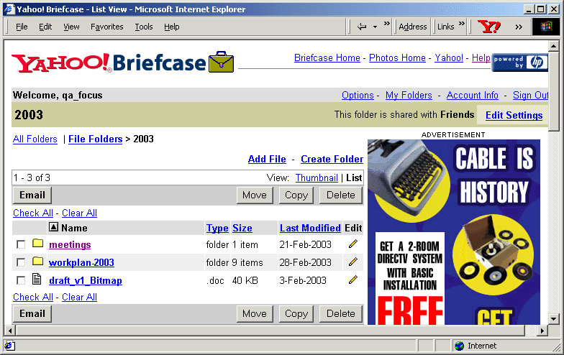
Figure 1: The MyYahoo briefcase

Yahoogroups Mailing List
A Yahoogroups mailing list [2] called qa-focus-team was also set up for internal QA Focus use. Yahoo encourage the use of user profiles allowing all their communication methods to be linked together. On setting up your own email account or a MyYahoo Web site you create a profile, this profile can then be assigned an email. Setting up the mailing list involved selecting a Yahoo! Groups Category and deciding on a group email address. Members are then enrolled or invited to join the group. Each individual member can then be configured, allowing them to post, receive and/or receive a copy of all messages to their usual daytime email addresses. The list is maintained and customised by the list owner and lists can be set up for public use or private use only. The main advantage of using the list is the creation of a comprehensive archive. This means that all email information is in an open space and not only held in one person's email box, whom may be on holiday or have changed jobs.

Blog
A Blog is a Web log held on the Internet which is updated frequently. Blogging has taken off in recent years and there is now a variety of free software allowing you to set up your own blog without any programming skills. One of the most famous blogs is blogger.com [3]. In order to record activities, ideas etc a blog was set up by the QA Focus team using Movabletype [4], a decentralised, Web based personal publishing system. The blog is currently only accessible internally and is used as a record of activities carried out during the week. These summaries will help with keeping note of work carried out and compiling reports. It is hoped that at a later date the blog will be open for external viewing.
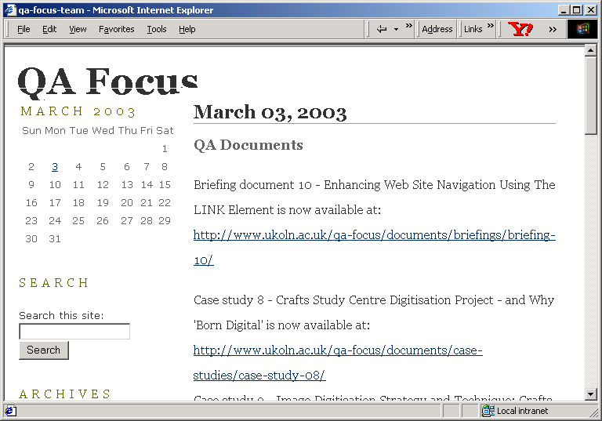
Figure 2: The QA Focus Blog

Instant Messaging
The QA Focus team have also experimented with forms of instant messaging. These are services that provide users with instantaneous contact with other Internet users. The main advantages of instant messaging are that you can carry out a real-time conversation while involved with other tasks. There is a much higher level of synchronicity than that achieved with an e-mail conversation, so it is useful for high priority work that needs group input.
At one stage the Yahoo IM tool was used. However due to the limitations of this tool members of the QA Focus team agree to move to use of the MSN Messenger tool. This is now used for regular virtual meetings with our remote worker and across the team as a whole. In addition the software is used for short-term tasks for which email is not required, such as arranging meetings.
Problems Experienced
Setting up the various communication tools is fairly straightforward but can be time-consuming. The real problem is getting users or members of a team to actually use the tools. The core QA Focus team only consists of three people so encouraging use has not been that much of an issue, but occasionally you do find yourself slipping back into old ways of working and using solely email.
Having a good communications infrastructure is key when working in a team, especially when members are distributed remotely. The important factor in establishing use is to document procedures and use the tools diligently at the start so use becomes second nature.
Things We Would Do Differently
The nature of QA Focus means that all experience and experimentation in a Web related area is always useful and gives us knowledge of both the problems and success areas. However if we had to repeat the process then maybe we would spend more time investigating the different tools available and document their advantages and disadvantages. Unfortunately as most people working on a project will know there is never enough time for research as anyone would like.
References
- MyYahoo, <http://my.yahoo.com/>
- Yahoogroups mailing list, <http://groups.yahoo.com/>
- Blogger.com, <http://www.blogger.com/>
- Movabletype, <http://www.movabletype.org/>
Contact Details
Brian Kelly
UKOLN
University of Bath
BATH
Tel: 01225 383943
Email: B.Kelly@ukoln.ac.uk

Acknowledgements
We are grateful to the following for contributing to the work of the QA Focus project:
Members of the JISC including Caroline Ingram our initial point of contact in JISC and Rachel Bruce and Balviar Notay, who provided valuable advice and support to the QA Focus team following Caroline’s departure from JISC.
Colleagues at UKOLN and the AHDS who provided valuable input to the work of the QA Focus project.
Others involved in JISC and related work who, knowingly or unknowingly, contributed to our work.

